 



Internship-II report submitted in partial fulfillment requirements for the award of degree of





Under the esteemed guidance of











(Affiliated to JNTU-K, Kakinada)

 







This is report on

“



Is a bonafide record of the internship work submitted





In their VII Semester in partial fulfillment of requirements for the Award of Degree of





During the academic year 







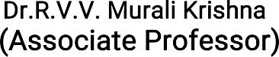



I hereby declare that this internship-2 entitled “



  is a bonafide work done by me and submitted to





 in partial fulfillment for the award of degree of B.Tech is of my own and it is not submitted to any other university or has been published any time before.

PLACE: Visakhapatnam G.BHARGAVI DATE: 21131A1213



I would like to express our deep sense of gratitude to our beloved institute 



 which has provided me an opportunity to full fill our cherished desire.

I thank our Course Coordinator and our Internship Mentor



Department of Information Technology for the kind suggestions and guidance for the successful completion of our internship.

We are highly indebted to 



for giving us an opportunity to do the

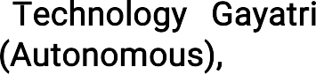internship in college.



We express our sincere thanks to our Principal  

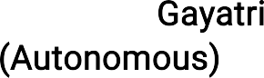





for his encouragement to us during this project, giving us a chance to explore and learn new technologies in the form of mini project.

We express our deepest thanks to the  for offering us this internship.



Finally, we are indebted to the teaching and non-teaching staff of the Computer Science and Engineering Department for all their support in completion of our project.





An overview of key concepts and methodologies in Artificial Intelligence (AI), Data Science, and Machine Learning (ML) from the Data Science Master Virtual Internship with RapidMiner, an Altair company, is presented. The internship covers foundational elements and advanced techniques used in data science. -Definitions, capabilities, and interrelations of AI, Data Science, and ML are discussed. The role of RapidMiner and the CRISP-DM framework is covered.

Key concepts include data visualization, model selection and evaluation, optimization techniques, and cost-sensitive learning. Details on setting up a local training database for AI Studio are provided, including database connection entries, data transformation, and basic ETL processes. Handling multiple datasets and performing pivot and aggregate operations are also discussed.ML validation, performance measures, feature engineering, parameter optimization, and model selection are addressed. This guide offers a valuable resource for understanding data science and machine learning, providing practical insights and advanced knowledge to practitioners.



 This course provides an introduction to the RapidMiner platform and the basics of machine learning. It covers essential functionalities of RapidMiner, the workflow- based approach to data science, and foundational machine learning concepts, allowing participants to quickly start building and deploying predictive models.

  Aimed at professionals, this course dives deeper into data science methodologies using RapidMiner. It includes advanced data preparation techniques, model development, evaluation, and deployment. Participants learn to handle real-world data challenges and apply best practices in data science projects.



  This comprehensive course focuses on mastering data science with RapidMiner. It covers end-to- end data science processes, including advanced machine learning algorithms, optimization techniques, and large-scale data handling. The course equips participants with the skills to tackle complex data science problems and implement robust solutions.

 This course explores practical applications and real-world use cases of data science across various industries. It highlights how data science can drive decision- making and innovation in fields such as finance, healthcare, marketing, and more. Participants gain insights into applying data science techniques to solve specific business problems.

 Focusing on the core aspects of machine learning, this course covers various supervised and unsupervised learning algorithms, model evaluation, and optimization techniques. It emphasizes practical implementation using RapidMiner, helping participants understand the intricacies of different machine learning models and their applications.



  This course delves into the data engineering aspects of data science. It covers data integration, ETL (Extract, Transform, Load) processes, data warehousing, and big data technologies.

Participants learn how to efficiently manage and preprocess data to support robust and scalable data science workflows.

These certifications have provided us with a solid foundation a

advanced knowledge in data science, machine learning, and the use of RapidMiner for various data-related tasks.

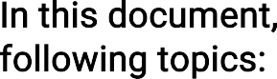

* 1. Data Science 12
  2. What is AI, ML, and Deep Learning 13
  3. What AI and ML can Do 15
  4. Methodoligies 17
  5. Rapid Miner and CRISP-DM 19
  6. Concepts of a Reference Architecture For ML 20
  7. From Descriptive to Predictive and Prescriptive 22
  8. Visualizing Data 24
  9. Model Selection and Evaluation 26
  10. Finding the Right Model 26
  11. Advanced Optimization Techniques 27
  12. Cost sensitive Learning 28
  13. Creating a Database Connection Entry 29
  14. Data Transformation 31
  15. Basic ETL Intro 32
  16. Multiple Data Sets 33
  17. Pivot and Aggregate 35
  18. Supervised Learning 40
  19. Scoring in Machine Learning 44
  20. Unsupervised Learning 45
  21. Association Analysis 47
  22. Loops and Macros 48
  23. Logging and Runtime 49
  24. Data Cleansing 49
  25. Outlier Detection 52
  26. Codes and Macros 53
  27. Text and Web 55
  28. Validation 56
  29. Performance Measures in ML 57
  30. Feature Engineering 59
  31. Parameter Optimization 60
  32. Model Selection 60
  33. Supervised Learning 61
  34. Ensembles 61
  35. Support Vector Machines 62
  36. Deep learning 62
  37. SparkRM 63
  38. Radoop 63
  39. Uncompromising security 63





Data Science is the practical application of various fields such as Artificial Intelligence (AI), Machine Learning (ML), and Deep Learning (DL) in a business context. The term "business" here is flexible and can also encompass scientific research. In this context, "business" refers to science itself, highlighting the broad applicability of data science.

* 

Regardless of the context, the primary goals of data science remain consistent:

* Extracting insights from data
* Predicting future developments
* Deriving optimal actions for desired outcomes
* Automating these actions when possible
* 

As illustrated in the diagram, Data Science encompasses more than just the application of AI, ML, and DL techniques. It also includes:

* Traditional statistics
* Data visualization
* Necessary data preparation for analysis

Data preparation is a critical component, often consuming the majority of a data scientist's time.

*  

A traditional definition of a data scientist describes an individual with a blend of programming skills, statistical knowledge, and business acumen. While this skill set is indeed valuable, it is not exhaustive.

* 

The reality is that effective data scientists can come from diverse backgrounds:

* Some may excel without writing a single line of code.
* Others may create predictive models using the right tools, even without a deep understanding of statistics.
*   

The notion of a "unicorn" data scientist, who masters all necessary skills simultaneously, is often impractical. Such individuals are not only hard to find but might also be unnecessary.

* Data scientists are individuals who apply analytical techniques and data preparation within a business context.
* The tools they use are less important as long as the results are accurate and reliable.

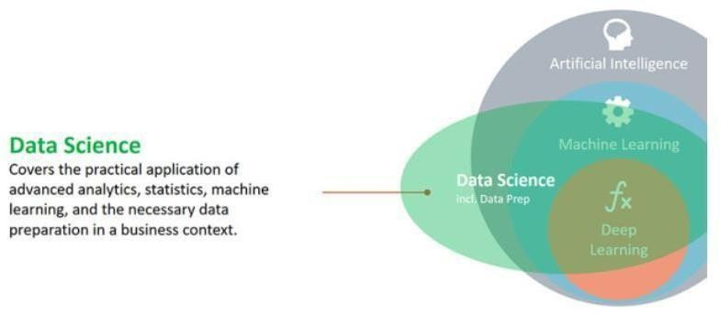

*  

Artificial Intelligence (AI), Machine Learning (ML), and Deep Learning (DL) have become integral to modern technology, frequently appearing in media and research. However, there is often confusion and skepticism surrounding these terms. This document aims to clarify their definitions and interrelationships.



*  

Artificial Intelligence encompasses any technology that enables computers to

perform tasks that typically require human intelligence. This includes natural language processing, robotics,

and computer vision. AI aims to simulate human cognitive functions and is exemplified by technologies like Siri or automatic trading systems.

*  



Machine Learning is a subset of AI focused on the development of algorithms that allow computers to learn from and make predictions based on data. ML algorithms identify patterns and adjust their actions based on new data, improving over time without explicit programming. This field includes techniques such as regression, decision trees, and clustering.

* 



Deep Learning is a specialized branch of Machine Learning that utilizes neural networks with many layers (hence "deep") to model complex patterns in large datasets. It includes techniques such as artificial neural networks, convolutional neural networks, and recurrent neural networks. DL has gained significant attention due to its success in areas like image and speech recognition.

*   



AI is the broadest category, encompassing all efforts to make machines intelligent. Within AI, ML represents the techniques that enable machines to learn from data. DL is a further specialization within ML, involving deep neural networks to handle complex tasks. Each of these fields builds upon the previous, contributing to the overall goal of creating intelligent systems.

*  

The research areas and applications within these fields are vast. AI includes natural language understanding, language synthesis, computer vision, robotics, sensor analysis, optimization, and simulation. ML encompasses methods such as support vector machines, decision trees, Bayes learning, k-means clustering, and association rule learning. DL focuses on advanced neural network architectures like convolutional neural networks, recurrent neural networks, long short-term memory networks, and deep belief networks.

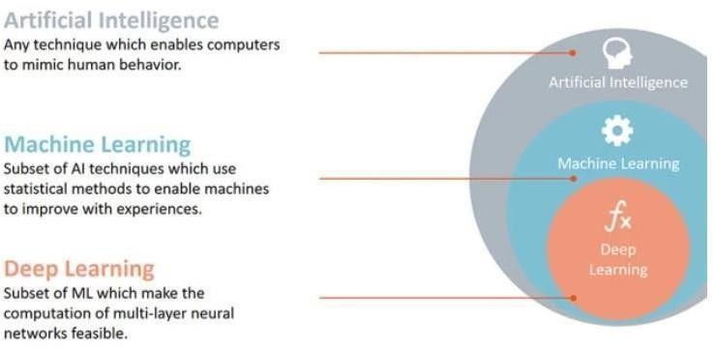



* 

Artificial Intelligence (AI) and Machine Learning (ML) have garnered significant attention in recent years. While their potential is vast, it is crucial to understand both their capabilities and limitations. This section explores the practical applications and boundaries of AI and ML.

* 



AI and ML are most effective when they are employed to make numerous similar decisions rapidly. This is where their true value lies. Examples of such applications include:

* : Adjusting the price of products in response to rapidly changing market demands.
* : Making personalized offers for cross- selling on e- commerce platforms.



* : Assessing and approving or rejecting credit applications.
* : Identifying customers who are at high risk of leaving a service.
* : Stopping fraudulent transactions in real-time.

In these scenarios, AI and ML models can process vast amounts of data and make decisions much faster than humans. For instance, sifting through a customer base of 50 million clients to identify high churn risk individuals is a task that is unmanageable for humans but straightforward for an ML model.

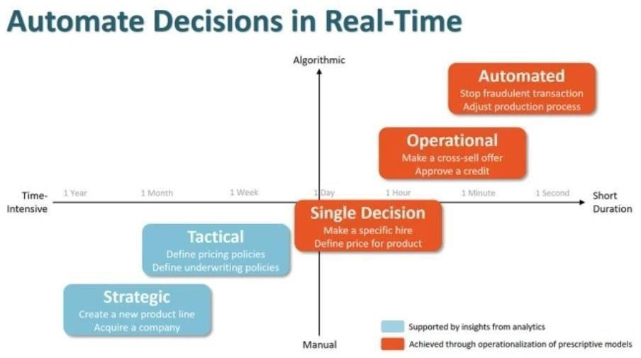



AI and ML are not well-suited for making single, strategic decisions. These decisions often require a level of strategic thinking and context that current AI and ML technologies cannot replicate. While analytics can assist by providing easier access to and visualization of data, the ultimate decision-making in such contexts is better left to human judgment.

Building a machine learning model or an AI system for a single significant decision is often not worth the effort, as these models do not necessarily yield better results than a well- informed human decision-maker. For example, strategic decisions about company direction or high-stakes policy choices typically require nuanced understanding and foresight that AI cannot provide.

* 

The greatest value of AI and ML lies in their ability to operationalize models and automate decisions on a large scale. The more decisions that can be automated, the higher the value derived from these technologies. This is illustrated in the decision spectrum, where the true impact of AI and ML is realized in situations requiring rapid, repetitive decision-making.

Andrew Ng, a prominent AI researcher, succinctly describes the utility of AI: AI excels in automating and operationalizing models, particularly for tasks that need to be repeated frequently. This emphasis on automation highlights the primary strength of AI and ML – their ability to handle large volumes of data and make numerous decisions swiftly and accurately.

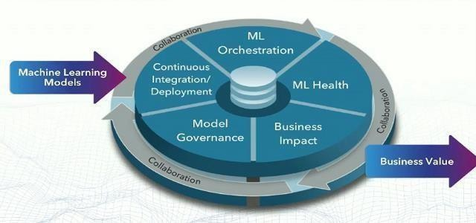





* 

In the realm of data science projects, the success or failure of a project often hinges on several critical factors. Common reasons for project failure include poorly managed expectations, misunderstanding of the business problem, selection of projects lacking significant potential value, unexpected technical challenges, lack of required skills, and insufficient stakeholder commitment. However, by adopting and customizing successful methodologies, organizations can significantly improve their project success rates.

* 

There are numerous methodologies that organizations can adopt, each tailored to fit the specific needs and contexts of the organization. The most effective methodologies align with the principles of the agile manifesto for software development. These methodologies can be broadly categorized into two types: program level and project level.



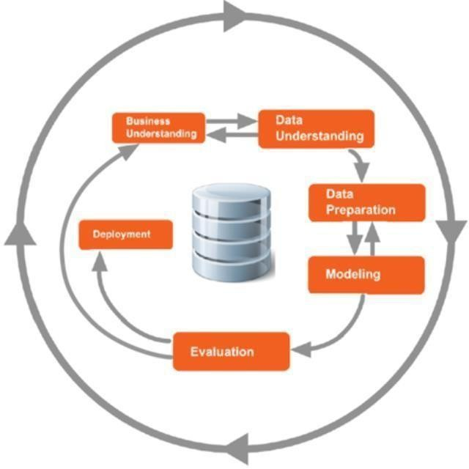

* 

Project-level methodologies are designed to ensure that team members focus their efforts on the right tasks at the right times. These methodologies do not necessarily address the overall development of the organization but are crucial for the successful execution of individual projects. A well-regarded project methodology in data science is CRISP-DM (Cross-Industry Standard Process for Data Mining).

CRISP-DM provides a structured approach for planning and executing data science projects, ensuring that project goals are met effectively and efficiently.

* 

In contrast, program-level methodologies oversee multiple projects within an organization. These methodologies help in the selection and support of valuable projects, establish standards that apply across projects, and ensure that the right people and roles are identified and involved. Furthermore, program-level methodologies address the organization's overall development, focusing on increasing data science maturity and upskilling employees. These methodologies often encompass project methodologies, providing a comprehensive framework for managing and executing data science initiatives.

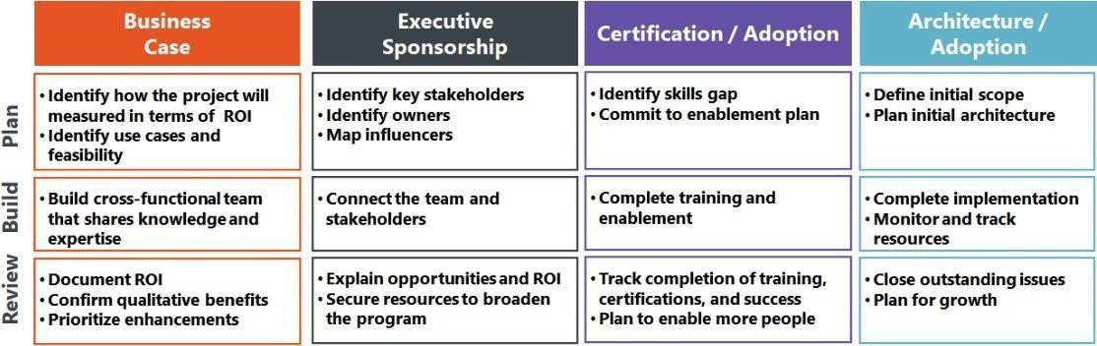



* 

Successful large or ambitious data science programs rely heavily on two critical components: Executive Sponsorship and Certification/Adoption.

 ensures that there is high-level support for data science initiatives, facilitating necessary resources and strategic alignment with organizational goals.

 involve upskilling employees and enhancing the data science maturity of the organization. This process includes training, certification programs, and encouraging the adoption of new tools and techniques across the organization.



*  

RapidMiner is a comprehensive data science platform that supports the end-to-end analytics lifecycle, providing tools for data preparation, machine learning, and predictive analytics. The RapidMiner ecosystem is designed to be user-friendly, enabling both novice and experienced data scientists to build robust data models efficiently.



*  

1. : This is the primary integrated development environment (IDE) for designing and deploying data science workflows. It offers a drag- and-drop interface that simplifies the process of building complex analytical processes.
2. : A scalable server for collaborative work, scheduling, and managing large-scale data science projects. It supports version control and collaborative model development, making it easier for

teams to work together.

1.  : This component facilitates automated machine learning (AutoML), model management, and deployment. It allows data scientists to automate repetitive tasks and focus on more strategic analytical work.
2. : An online repository where users can share and download extensions and additional functionalities to enhance the capabilities of RapidMiner Studio.
   *   



To begin working in RapidMiner Studio, follow these steps to set up your environment:

1. : Download and install the latest version of RapidMiner Studio from the official website.



1. : Organize your work by creating a new project. This helps keep related datasets, processes, and results together.
2.  : Use the built-in data import tools to bring in data from various sources, including databases, spreadsheets, and cloud storage.
3. : Customize your workspace to fit your workflow by arranging panels and toolbars to your preference.
4.  : Enhance the functionality of RapidMiner Studio by installing relevant extensions from the RapidMiner Marketplace.



The CRISP-DM (Cross-Industry Standard Process for Data Mining) is a widely adopted methodology for data mining and machine learning projects. It provides a structured approach to planning and executing data science projects. The CRISP- DM process consists of six phases:

1. : Define the project objectives and requirements from a business perspective. This phase involves identifying the key business questions that need to be answered.
2. : Collect initial data and familiarize yourself with it. This includes data exploration and quality assessment to identify any issues that need to be addressed.
3.  : Prepare the data for modeling by cleaning, transforming, and selecting relevant features. This phase often consumes a significant portion of the project timeline.
4. : Apply various modeling techniques to the prepared data. This involves selecting the appropriate algorithms and tuning them to achieve the best performance.
5. : Evaluate the model to ensure it meets the business objectives and criteria for success. This phase includes validation and testing to assess the model’s accuracy and reliability.
6. : Deploy the final model into a production environment where it can be used to make predictions and provide insights. This phase also includes monitoring and maintaining the model over time.
   *  



RapidMiner Studio seamlessly supports the CRISP-DM methodology, allowing data scientists to navigate through the different phases effectively. Here’s how you can integrate CRISP-DM with RapidMiner:

1. : Use RapidMiner’s reporting tools to present findings and project plans to stakeholders, ensuring alignment with business objectives.
2. : Utilize RapidMiner’s data exploration and visualization capabilities to gain insights into the data.
3. : Leverage RapidMiner’s extensive data preparation operators to clean, transform, and prepare data for modeling.
4. : Access a wide range of machine learning algorithms and modeling tools available in RapidMiner Studio to build and refine models.
5. : Use RapidMiner’s evaluation operators to test and validate models, ensuring they meet the desired performance criteria.
6. : Deploy models directly from RapidMiner Studio to RapidMiner Server or other production environments, and monitor their performance over time.



* + 

The increasing global competition necessitates continuous optimization of products and processes in the process industry. Traditional methods like Lean Management and Six Sigma, while effective, are reaching their limits as new challenges arise from advancements in connectivity, specifically through the Industrial Internet of Things (IIoT) and machine learning (ML). These modern technologies present both opportunities and challenges for industries seeking to enhance efficiency and innovation.



The process industry faces significant hurdles in fully leveraging machine learning and artificial intelligence:

1.  Basic operations such as comminution, drying, filtration, and chemical reactions are becoming increasingly complex. The integration of biological processes adds another layer of complexity, requiring sophisticated analytical methods to manage and optimize these operations.
2.   The process industry deals with a large number of variables that influence outcomes. Understanding the cause and effect relationships among these variables requires advanced multivariate analysis techniques.
3.  With the growth of digitalization, the volume of data generated is immense. Traditional data analysis methods are inadequate for

managing and extracting actionable insights from such large datasets. This necessitates the development of robust IT architectures and data management systems.

1.  Many industrial projects struggle to move beyond the deployment phase due to a lack of established structures for data integration, model training, deployment, and maintenance.
   * 

The proposed reference architecture aims to address these challenges by providing a structured approach to integrating machine learning into the process industry. The architecture encompasses several critical components:

1.   Establishing robust pipelines for collecting and integrating data from various sources within the industry. This includes sensor data, operational logs, and external data sources.
2.  Creating environments and tools for training machine learning models. This involves setting up scalable computing resources and leveraging modern ML frameworks.
3.  Developing standardized processes for deploying machine learning models into production environments. This ensures that models can be used reliably and consistently across different parts of the organization.
4.  Implementing systems for continuous monitoring and maintenance of deployed models. This includes performance tracking, anomaly detection, and automated retraining.
   * 

The adoption of a standardized reference architecture brings several benefits:

* +  By standardizing processes and tools, the architecture enhances the efficiency of model development and deployment, allowing organizations to scale their ML initiatives more effectively.
  +  Advanced analytics and machine learning models provide deeper insights into operations, enabling more informed decision- making.
  +   Organizations that effectively implement this architecture can achieve a significant competitive advantage through optimized processes and innovative solutions.



* +  

Analytics refers to the skills, technologies, applications, and practices for continuous iterative exploration and investigation of data to gain insight and drive business decision-making.

* +   :

Traditionally focuses on using a consistent set of metrics to measure past performance and guide business planning. It consists of querying, reporting, OLAP

(online analytical processing), and can provide insights into what happened, how many, and how often.

* + :

Goes beyond BI by using sophisticated techniques to predict future outcomes or trends. It uses predictive modeling, data mining, and other methods to forecast what will happen, what will happen if we change something, and what's next.

* +    :

BI focuses on the storage and retrieval of past data, while advanced analytics focuses on predicting future trends. BI helps interpret data, while advanced analytics provides meaningful and useful information for business purposes.

* +     :

Contribute to advanced analytics by providing methodologies and technologies to process and analyze data effectively. They play a vital role in the development of advanced analytics by enriching model building and covering necessary data integration steps.

* + :

Is the practice of analyzing data to make statistically accurate predictions about future events. It uses techniques from statistics, machine learning, and data mining to extrapolate future events based on historical and transactional data.

* + :

Focuses on understanding patterns found in historical and transactional data to describe what happened in the past and what is happening now.

* +   :

Examples include fraud detection in financial services, predicting bankruptcy in business development, and identifying potential accidents in insurance underwriting.

* + 

Prescriptive analytics is a cutting-edge field that focuses on using data and analytics to suggest actions to optimize outcomes. It goes beyond predicting what will happen and

provides recommendations on what actions to take to achieve desired outcomes. This is particularly valuable in business settings, where making informed decisions can lead to significant improvements in efficiency and effectiveness.

* + 

Prescriptive analytics leverages machine learning models to analyze data and predict future outcomes. These models are trained on historical data to identify patterns and make predictions. Additionally, prescriptive analytics uses optimization techniques to determine the best course of action based on these predictions.

Optimization algorithms help find the most efficient solution to a given problem, considering various constraints and objectives.

* + 

The real value of prescriptive analytics lies in its ability to not only predict future outcomes but also to suggest actions to change those outcomes. For example, in a business context, prescriptive analytics can be used to optimize supply chain operations by recommending the most cost-effective distribution routes or inventory levels based on predicted demand.

* + 

Ingo Mierswa, RapidMiner's data science expert, exemplifies the positive attitude towards prescriptive analytics by humorously discussing whether to bring an umbrella based on weather predictions. This light-hearted example underscores the practical application of prescriptive analytics in everyday decision-making.



* +   

Data visualization plays a crucial role in translating complex data into easily understandable visual representations. It aids in interpreting data patterns, trends, and outliers, facilitating informed decision-making by business stakeholders.

However, the effectiveness of data visualization hinges on the principles of graphical perception, which are often overlooked in various stages of the data science pipeline.

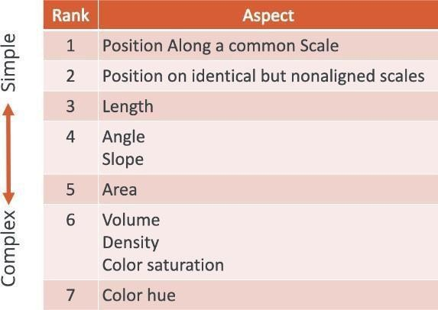



* + 

Graphical perception refers to the human ability to interpret visual information presented in graphs, charts, and maps. William Cleveland's work in data visualization has significantly influenced best practices in creating clean and minimalistic charts. Understanding graphical perception is essential for choosing the most appropriate visualizations for conveying data insights.

* + 

The hierarchy of graphs ranks perception parameters from simple to complex. For instance, a graph showing the position along a common scale is easier to interpret than one using color hue. Following best practices in graphical design ensures that visualizations are simple, interpretable, and effectively convey the intended message.

* + 

Using the Customer Churn dataset in RapidMiner Studio, descriptive analytics techniques can be applied to summarize and analyze the data. This includes calculating descriptive statistics, such as mean and standard deviation, and using visualizations like histograms and box plots to understand the distribution and relationships within the data.

* + 

Descriptive analytics summarizes datasets to reveal patterns and trends. Techniques include calculating descriptive statistics and using visualizations like histograms to understand the distribution of data points.

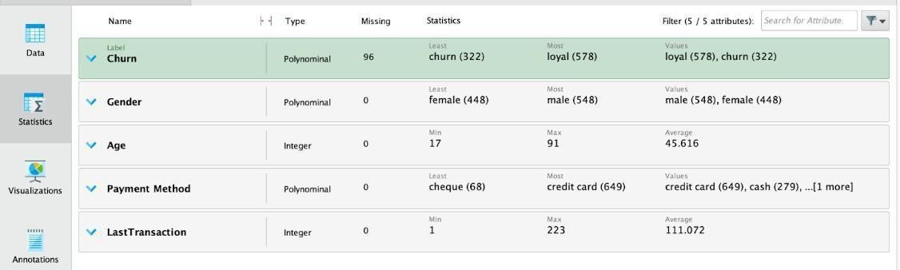

Univariate analysis focuses on analyzing a single variable or feature in a dataset. Histograms are effective for visualizing the frequency distribution of integer type features, while box plots are useful for comparing multiple attributes.

* + 

Bivariate and multivariate analysis techniques are useful for visualizing relationships between two or more attributes. RapidMiner Studio offers various visualization techniques, such as scatter plots and correlation matrices, for in-depth data analysis.



* + 

When selecting a model for your machine learning task, it's important to consider several factors to ensure the chosen model performs well and meets your specific requirements. Here are some guidelines to help you make an informed decision:



* + Compare the performance of different models using a validation dataset.
  + Choose the model with the best performance metrics, such as accuracy, precision, recall, or F1 score.



* + Balance model complexity with performance. A simpler model may be easier to interpret and faster to compute, but it may sacrifice some performance.
  + If the problem is more linear in nature, simpler models like linear regression or logistic regression may perform better than highly non- linear models like k-NN.



* + Choose a model that is easy to understand and explain, especially if stakeholders need to comprehend the model's decision-making process.
  + Consider the trade-off between model complexity and interpretability.



* + Fine-tune the parameters of your chosen model to further improve its performance.
  + Use techniques like grid search or random search for hyperparameter optimization.



* + Consider using automated model selection features, such as RapidMiner's Auto Model, to streamline the process and find the best model for your data automatically.





Choosing the right model for a machine learning task is crucial for achieving optimal performance and results. The process begins with a clear understanding of the problem statement and the type of problem being solved, whether it's classification, regression, clustering, or another type of task. Identifying key metrics for evaluating model performance, such as accuracy, precision, and recall, is essential at this stage.

* + 



Next, it's important to explore the different types of machine learning models available, including decision trees, random forests, support vector machines, and neural networks, among others. Consider the nature of the data you're working with—whether it's linear or non-linear—and the complexity of the problem you're trying to solve.

* + 

To evaluate model performance, split your data into training and testing sets. Train multiple models on the training data and evaluate each model's performance on the testing data using

appropriate metrics. Techniques like cross-validation can help ensure robust evaluation and prevent overfitting.

* +  

ROC curves are useful for visualizing and comparing the performance of different models, especially in binary classification tasks. Plotting the ROC curve for each model and comparing their AUC (Area Under the Curve) values can help you choose the model with the highest AUC, indicating better performance.

* + 

Consider using automated model selection tools, such as RapidMiner's Auto Model feature, to streamline the process. These tools can help identify the best- performing model for your dataset without manual intervention.

* +  

Iterate on your model selection process, trying different models and parameters, and refine your approach based on the performance metrics and insights gained from each iteration. Take into account practical considerations such as model interpretability, computational resources, and runtime requirements when choosing a model.



* +  

One approach to advanced optimization in RapidMiner involves embedding the most promising models into individual optimization processes. This step aims to streamline the comparison of various models based on their performance.

* + 

After embedding the models, they are executed one by one. This allows for a direct comparison of their performance metrics, such as accuracy, precision, recall, and F1-score. By executing the models individually, it becomes easier to analyze and identify the best- performing model for a given dataset.

* + 

During the optimization process, RapidMiner stores the best parameter combinations for each model. This information is crucial for replicating the optimized models and for future

reference. Storing these combinations ensures that the best-performing models can be easily identified and reused.

* + 

One of the key benefits of storing the best parameter combinations is the ability to repurpose them for generating ROC (Receiver Operating Characteristic) curves.

These curves plot the true positive rate against the false positive rate, providing a visual representation of the model's performance. By comparing the ROC curves of different models, data scientists can make informed decisions about which model to select for deployment.

* +  

Advanced optimization techniques in RapidMiner offer several benefits. They improve the efficiency of the model selection process by automating the comparison of multiple models. They also enhance the effectiveness of the selection process by providing a systematic approach to evaluating model performance. Additionally, these techniques enable data scientists to quickly identify the best-performing models and deploy them in production environments.





Generating a model to predict a certain outcome is one thing, but connecting details like AUC or accuracy with a meaning so that others can understand the value of the model is a different story. Cost-sensitive scoring or cost-sensitive learning is a great way to achieve that. Cost- sensitive learning involves optimizing a model according to the cost-saving impact rather than solely focusing on achieving the highest accuracy.

* +  

Cost-sensitive learning is not only useful as a means of communication but it is also possible and advisable to optimize a model according to the cost-saving impact. This approach ensures that the model is not only accurate but also cost-effective, which is particularly important in scenarios where the cost of misclassification is high.

* + 



Cost-sensitive learning can be applied in various real-world scenarios. For example, in healthcare, misdiagnosing a patient can have serious consequences. By optimizing a model to minimize the cost of misdiagnosis, healthcare providers can improve patient outcomes while also reducing costs.

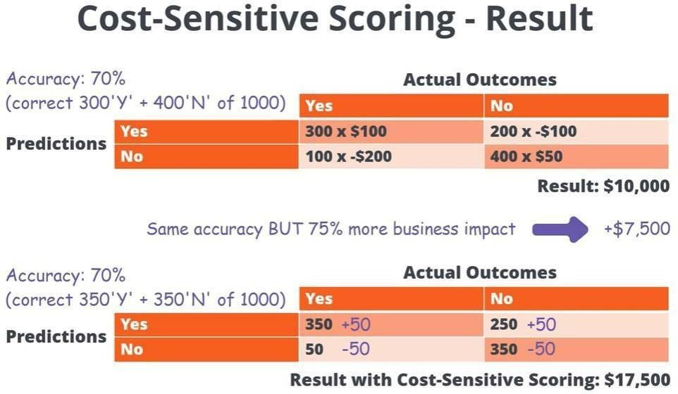







To create a database connection in AI Studio, follow these steps:

1. Open your Local Repository and right-click on Connections. Select “Create Connection”.
2. In the new dialog, set the Connection Type as Database and enter a Connection Name, e.g., TrainingResourcesDB.
3. In the Setup tab, select “HSQLDB Server” as the Database system. Enter the user name as “SA” and no password.
4. Select “Configure URL manually” and specify a path for your database file, e.g., C:\Users\yourname\RMTrainingResourcesDB. Enter the database connection URL as jdbc:hsqldb:file:<filePath>.

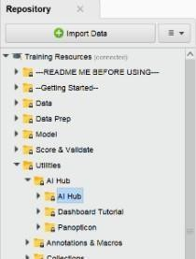

* + 

To execute the training resources database example processes, proceed as follows:



1. Navigate to the Training Resources repository and open Utilities/AI Hub.
2. Save the tutorial processes into the Local Repository.
3. Execute the “Setup database” process to put prepared data into the configured database. Set the “define connection” to “repository” and select the database connection entry.
   * 

HyperSQL is a useful database system for single users. It can be used for storing data centrally instead of keeping them in single CSV files or for learning and experimenting with the full power of SQL databases on your computer. While not a replacement for enterprise database systems, it can be used for reasonable data sizes in a small team.

* + 

 Organizing views in RapidMiner allows for a clearer and more efficient workflow. Views can be arranged to suit your preferences and make it easier to navigate through processes.

 To organize views, simply click and drag them to the desired location. Views can be docked to different sides of the RapidMiner Studio window or placed in floating windows.

 Views can be customized by right-clicking on the view tab and selecting options such as hiding or showing specific views, changing the layout, or resetting the view to its default state.

* + 

 Subprocesses in RapidMiner are encapsulated processes that can be

reused within a larger process. They help in organizing complex workflows and promoting reusability of components.

 To create a subprocess, select the components you want to include, right-click, and choose "Encapsulate as Subprocess." Give the subprocess a name and it will appear as a single component in your process.

: Subprocesses can be used by dragging them into your process flow. Double-clicking on a subprocess opens it for editing, allowing you to make changes to the encapsulated components.

* + 



 Building blocks in RapidMiner are pre-built components or processes that provide common functionality. They can be used to quickly add functionality to your processes without having to build it from scratch.

 Building blocks can be accessed from the "Operators" panel. Simply drag a building block into your process to add its functionality.

:Building blocks can be customized to suit your specific needs. You can modify the parameters and settings of a building block to make it work for your particular use case.

* + 

Breakpoints in RapidMiner are markers that pause the execution of a process at a specific point. They are useful for debugging and troubleshooting complex processes.

 To set a breakpoint, right-click on an operator and select "Toggle Breakpoint." When the process reaches this operator during execution, it will pause, allowing you to inspect the data and the state of the process.

 Breakpoints can be used to step through a process one operator at a time, making it easier to identify and fix issues. They can also be used to inspect the data at various points in the process flow.



Data transformation is a fundamental process in data preprocessing that involves converting data from its original format to a format that is more suitable for analysis. In RapidMiner, data transformation is carried out using a variety of operators and tools that allow you to manipulate, clean, and restructure your data. Here are some key aspects of data transformation in RapidMiner:

* +   Data cleaning is the process of identifying and correcting errors or inconsistencies in the data. This can include removing duplicate records, correcting spelling mistakes, and handling missing values.
  +   Filtering allows you to extract only the data that meets specific criteria. This can help you focus on relevant data and remove noise or irrelevant information.
  +  Aggregating data involves combining multiple rows of data into a single row based on a common attribute. This can be useful for summarizing data or creating new features for analysis.
  +  Joining data involves combining data from two or more sources based on a common attribute. This allows you to create a single dataset that contains information from multiple sources.
  +  Pivoting data involves reorganizing data from a long format to a wide format or vice versa. This can be useful for creating summary tables or visualizations.
  +  Normalizing data involves scaling the values of numeric attributes to a standard range, such as between 0 and 1. This can help

prevent bias in machine learning models that are sensitive to the scale of the input data.

* +   Transforming data types involves converting the data from one data type to another. This can be necessary when the original

data type does not match the requirements of the analysis or when merging data from different sources.

* +   Feature engineering involves creating new features from existing data to improve the performance of machine learning models. This can include creating interaction terms, polynomial features,

or transforming existing features into more useful representations.



Data transformation in RapidMiner often follows the Extract, Transform, Load (ETL) process, where data is extracted from various sources, transformed into a suitable format, and then loaded into a target destination. This process is fundamental in preparing data for analysis and modeling.

* + 



Filtering examples involves selecting or excluding examples from a dataset based on certain conditions. For example, you can filter out rows where a specific attribute falls within a certain range or meets a specific criteria.

* + 

Mapping and replacing values in a dataset allows you to transform the values of one attribute into another. This can be useful for standardizing categorical values or converting them into a format that is more meaningful for analysis.

* + 



Replacing missing values is a common data preprocessing step where missing values in a dataset are replaced with a specified value, such as the mean, median, or mode of the attribute.

* +  



Converting date attributes to numeric format allows you to perform calculations or analyses that require numerical values. This transformation is often necessary when working with time-series data.

* +  



Converting numeric attributes to nominal format is useful when the numeric values represent categories or labels. This transformation can help simplify the analysis of categorical data.

* + 

Generating new attributes involves creating new features based on existing ones. This can include combining existing attributes, creating interaction terms, or applying mathematical transformations.

* + 

Selecting attributes involves choosing which attributes to include or exclude from a dataset based on their relevance to the analysis. This step helps reduce the dimensionality of the dataset and focus on the most important features.

These basic ETL operations form the foundation of data transformation in RapidMiner, allowing you to prepare your data for analysis and modeling effectively.



Working with multiple datasets in RapidMiner allows you to combine, compare, and analyze data from different sources. This capability is essential for tasks such as data integration, data

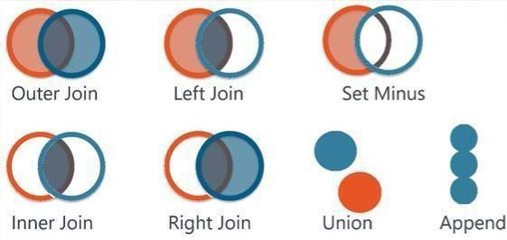

blending, and dataset comparison. RapidMiner provides several operators and tools to facilitate the handling of multiple datasets.

* + 

The Union operator combines two or more datasets with the same structure into a single dataset. This is useful when you have multiple datasets containing similar information that you want to merge into a single dataset.

* + 

The Join operator combines two datasets based on a common attribute. It allows you to merge datasets that share a common key, such as an ID or a date. Joins can be performed using different join types, such as inner join, outer join, left join, and right join.

* + 

The Append operator appends one dataset to another, adding the rows of one dataset to the end of another dataset. This is useful when you want to combine datasets vertically, adding new records to an existing dataset.

* + 

The Loop operator allows you to iterate over multiple datasets or perform a series of operations on each dataset in a collection. This is useful when you need to apply the same set of operations to multiple datasets.

* + 

The Merge operator merges two datasets into a single dataset, combining the rows of both datasets. Unlike the Union operator, the Merge operator does not require the datasets to have the same structure. It can merge datasets with different attributes, combining them based on common attributes.

* + 

Cross-validation is a technique used to assess the performance of a predictive model by dividing the dataset into multiple subsets, training the model on some subsets, and testing it on others. RapidMiner provides operators for performing cross-validation on multiple datasets, allowing you to evaluate the performance of your models across different datasets.

* + 



Data blending is the process of combining data from different sources to create a unified view of the data. RapidMiner provides tools for blending data from multiple datasets, allowing you to create comprehensive analyses that incorporate data from diverse sources.



Pivot and aggregate operations are fundamental for reshaping and summarizing data in RapidMiner. These operations are particularly useful for transforming raw data into a format suitable for analysis and visualization. The pivot operation allows you to reorganize data from rows into columns, while the aggregate operation enables you to summarize data based on specified criteria.

The pivot operation in RapidMiner allows you to transform long-format data into wide- format data by pivoting on a specified attribute. For example, if you have a dataset where each row represents a single observation, and you want to pivot the data so that each unique value of a certain attribute becomes a separate column, you can use the pivot operator to achieve this. This is particularly useful for tasks such as creating pivot tables or preparing data for analysis in spreadsheet software.

The aggregate operation in RapidMiner allows you to summarize data by grouping it based on one or more attributes and applying an aggregation function to the grouped data. Common aggregation functions include sum, count, average, minimum, and maximum. For example, if you have a dataset containing sales data for multiple products and you want to calculate the total sales for each product, you can use the aggregate operator to group the data by product and sum the sales values for each group.

By combining pivot and aggregate operations, you can perform complex data transformations and summarizations in RapidMiner. These operations are essential for preparing data for analysis and generating meaningful insights from raw data.

Pivot, aggregate, and set minus operations are essential data transformation techniques in RapidMiner that enable users to manipulate and reshape data for analysis and reporting purposes.

* +  The pivot operation in RapidMiner allows you to reorganize data from long- format to wide-format by pivoting on a specified attribute. This is useful when you want to transform data so that each unique value of a certain attribute becomes a separate column. For example, if you have a dataset where each row represents a sales transaction and you want to pivot the

data so that each product category becomes a separate column, you can use the pivot operator to achieve this.

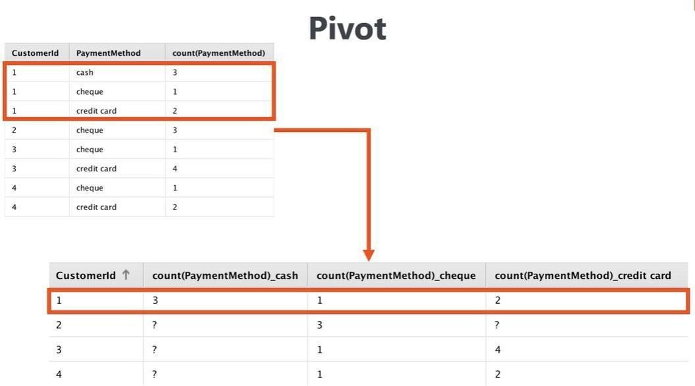



* + The aggregate operation in RapidMiner is used to summarize data by grouping it based on one or more attributes and applying an aggregation function to the grouped data. Common aggregation functions include sum, count, average, minimum, and maximum. For example, if you have a dataset containing sales data for multiple products and you want to calculate the total sales for each product, you can use the aggregate operator to group the data by product and sum the sales values for each group.

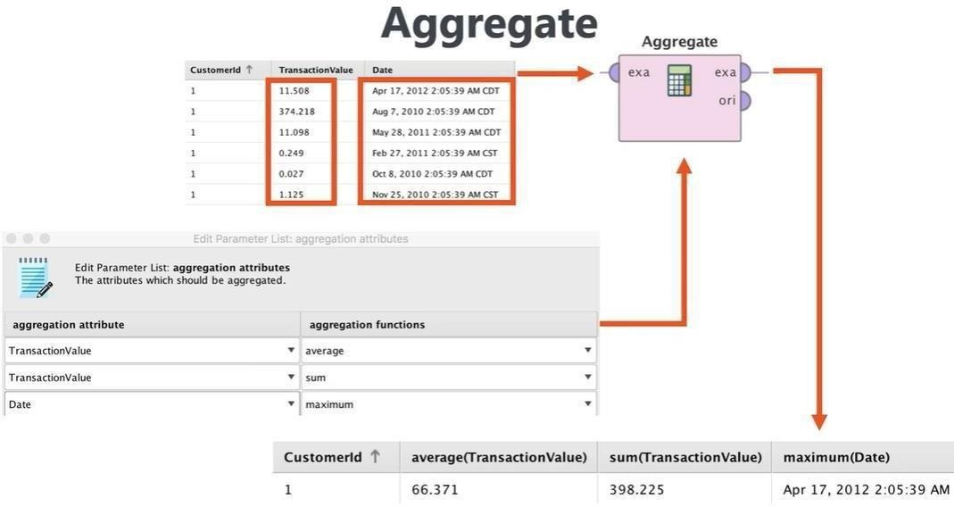

* +   The set minus operation in RapidMiner is used to subtract the records in one dataset from another dataset. It is similar to the set difference operation in set theory.



Machine learning is a field of artificial intelligence (AI) that focuses on the development of algorithms and models that enable computers to learn from and make predictions or decisions based on data. Unlike traditional computer programs that are explicitly programmed to perform a specific task, machine learning algorithms are designed to learn from data and improve their performance over time without being explicitly programmed.



three main types:

Machine learning can be broadly classified into

In supervised learning, the algorithm is trained on a



labeled dataset, where each example in the dataset is associated with a label or output. The goal of supervised learning is to learn a mapping from input variables to output variables, such as predicting the price of a house based on its features like size, location, etc.

 Unsupervised learning involves training the algorithm on an unlabeled dataset, where the algorithm tries to find hidden patterns or structure in the data. Clustering is a common unsupervised learning technique where the algorithm groups similar data points together.

 Reinforcement learning is a type of machine learning where an agent learns to make decisions by interacting with an environment. The agent receives feedback in the form of rewards or penalties based on its actions and uses this feedback to learn the optimal strategy.

 Machine learning has a wide range of applications across various industries, including:

 Machine learning is used for disease diagnosis, personalized treatment plans, and drug discovery.

 Machine learning is used for fraud detection, risk assessment, and algorithmic trading.

 Machine learning is used for customer segmentation, targeted advertising, and recommendation systems.

 Machine learning is used for route optimization, autonomous vehicles, and traffic prediction.

 While machine learning has made significant advancements in recent years, there are still several challenges that researchers and



practitioners are working to address. These include:

  Machine learning algorithms are highly dependent on the quality and quantity of data. Ensuring that the data is clean, relevant, and representative is crucial for the success of machine learning projects.

 Many machine learning models, especially deep learning models, are often seen as black boxes, making it challenging to interpret their decisions.

Increasing the interpretability of these models is an area of active research.

 As machine learning algorithms are used in more critical decision-making processes, there are growing concerns about bias, fairness, and accountability. Addressing these concerns and ensuring that machine learning is used ethically and responsibly is a priority for the future of the field.

* 

The k-Nearest Neighbors (k-NN) algorithm is a simple yet powerful machine learning algorithm used for classification and regression tasks. It is a type of instance-based learning, where the model memorizes the training instances and makes predictions based on their similarity to new, unseen instances.

For classification tasks, each data point is assigned a class label, and the algorithm predicts the class of a new data point based on the classes of its k nearest neighbors. For regression tasks, the algorithm predicts a continuous value based on the average or weighted average of the values of its k nearest neighbors.

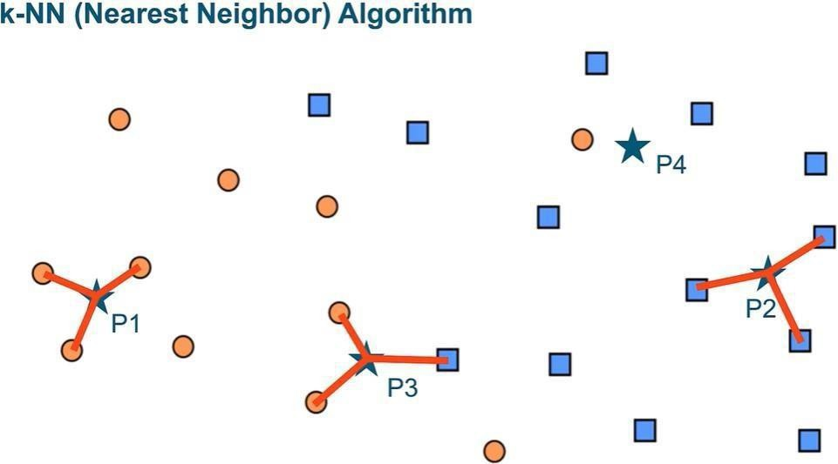

*  



Model validation is a crucial step in the machine learning pipeline to ensure that the trained model performs well on unseen data. It helps to estimate the model's performance and generalization ability. There are various techniques for model validation, such as holdout validation, k-fold cross-validation, and leave-one-out cross- validation.

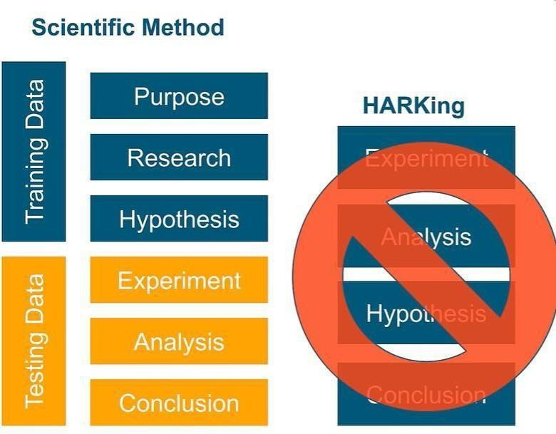

*   

Normalization is a data preprocessing technique used to scale the features of a dataset to a similar range. It helps to improve the performance of machine learning models, especially when the features have different scales or units. Common normalization techniques include min-max scaling and z-score normalization.

By scaling the features to a similar range, you can improve the model's convergence speed and accuracy. The effect of normalization on the distribution of feature values and the performance of the model.

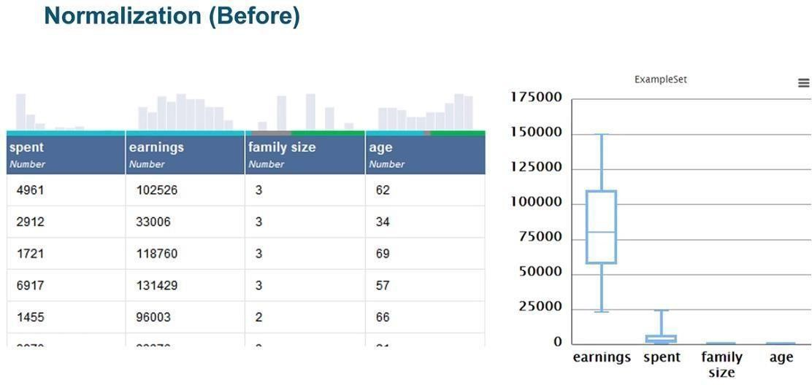

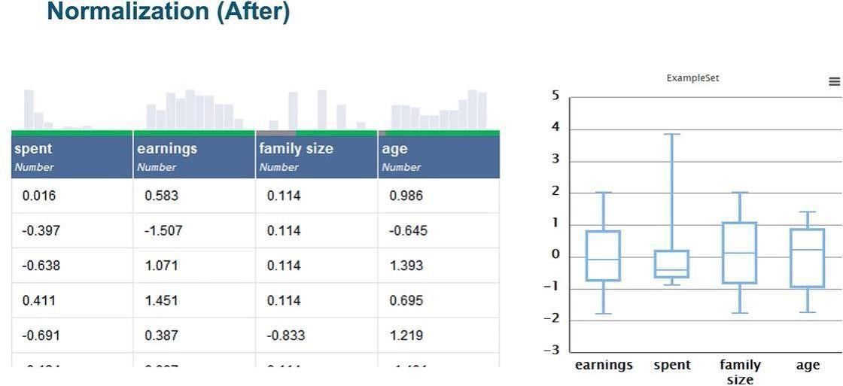

* 



To correctly validate machine learning models, it is essential to follow best practices and avoid common pitfalls. This includes using appropriate validation techniques, such as cross- validation, to ensure that the model's performance is accurately estimated. It also involves selecting evaluation metrics that are suitable for the specific task and dataset, and avoiding overfitting by tuning the model's hyperparameters carefully.



Supervised learning is a machine learning paradigm where the model is trained on a labeled dataset, meaning that each training example is paired with the correct output. The goal of supervised learning is to learn a mapping from input variables to output variables, so that the model can make accurate predictions on new, unseen data.

In supervised learning, the dataset is divided into two parts: the training set and the test set. The training set is used to train the model, while the test set is used to

evaluate its

performance. The model learns the relationship between the input and output variables by minimizing a loss function, which measures the difference between the predicted output and the actual output.



There are two main types of supervised learning tasks: classification and regression. In classification tasks, the model predicts a class label for the input data, while in regression tasks, the model predicts a continuous value. Common algorithms used in supervised learning include decision trees, random forests, support vector machines, and neural networks.

One of the key challenges in supervised learning is overfitting, where the model learns the training data too well and performs poorly on new data. To address this, techniques such as cross-validation, regularization, and feature selection can be used to improve the generalization ability of the model.

* 

Linear regression is a foundational statistical method used to model the relationship between a dependent variable and one or more independent variables. It assumes a linear relationship between the dependent variable and the independent variable(s), meaning that a change in the independent variable(s) is associated with a proportional change in the dependent variable.

This method is commonly used for forecasting and making predictions based on historical data. For example, in economics, linear regression can be used to predict future sales based on past sales data and other relevant factors like advertising expenditure or seasonality.

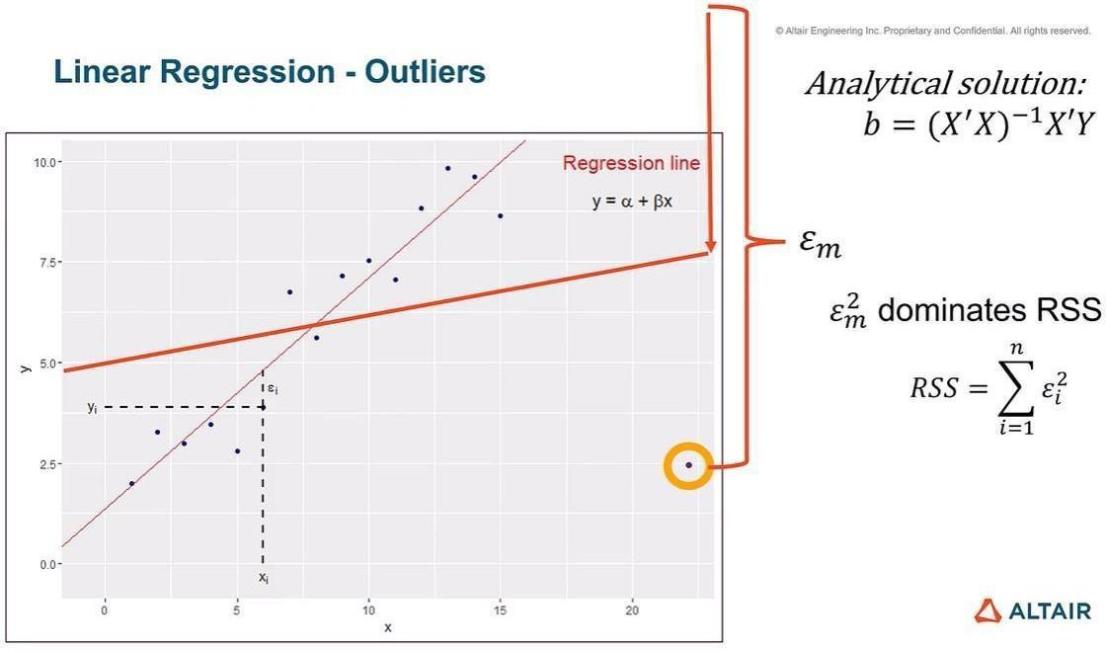

Logistic regression is a type of regression analysis used when the dependent variable is binary, meaning it takes only two possible outcomes. It models the probability that the dependent variable belongs to a particular category based on one or more independent variables. Logistic regression is widely used in various fields, including medicine for predicting the likelihood of a disease based on patient characteristics, or in marketing for predicting the probability of a customer buying a product based on demographic information.

Generalized Linear Models (GLMs) extend the concept of logistic regression to handle non- normal error distributions and more complex relationships between the dependent and independent variables. GLMs are flexible and can accommodate different types of response variables, making them useful in situations where traditional linear regression or logistic regression may not be appropriate.

* 

Naive Bayes is a simple but effective probabilistic classifier based on Bayes' theorem and the assumption of independence between features. Despite its simplicity, Naive Bayes is often used in text classification tasks, such as spam detection and sentiment analysis, where it can perform well and be computationally efficient. Naive Bayes calculates the probability of each class for a given set of features and predicts the class with the highest probability.

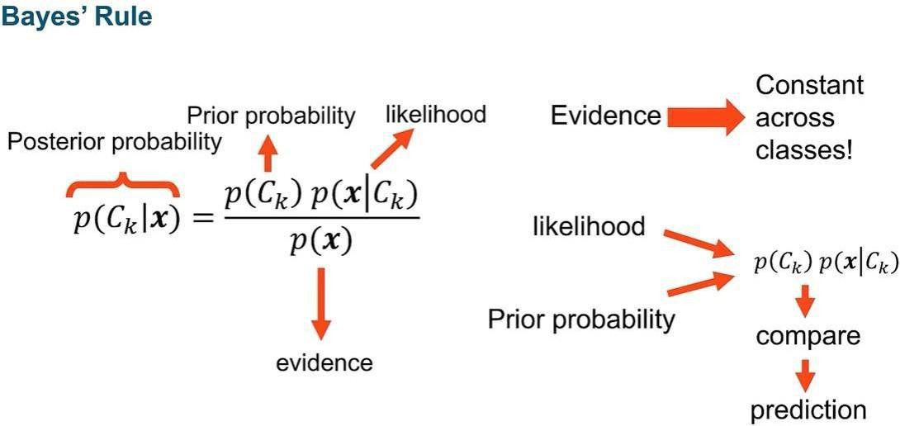

*  

Decision trees are versatile and easy-to-understand supervised learning models that can be used for both classification and regression tasks. They work by recursively partitioning the input space into regions, with each partition represented by a tree node. At each node, the decision tree algorithm selects the feature that best splits the data, based on criteria such as information gain or Gini impurity, to maximize the

homogeneity of the target variable within each partition.

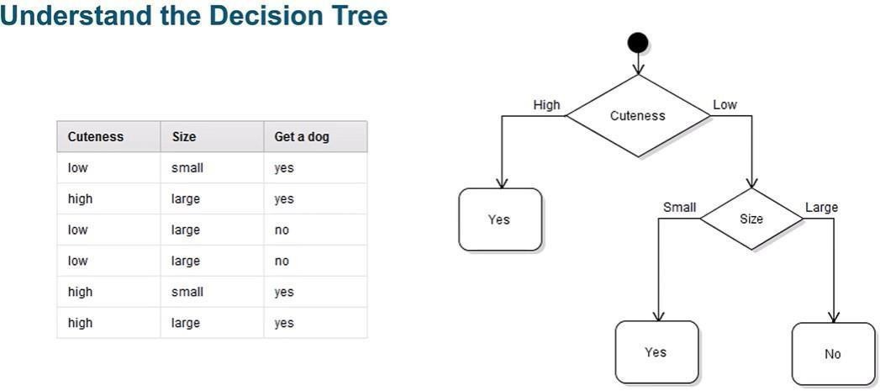



* 

Neural networks are a class of deep learning models inspired by the structure and function of the human brain. They consist of interconnected nodes, or neurons, organized into layers.

Each neuron applies a weighted sum function to its inputs, followed by a non-linear activation function. Neural networks can learn complex patterns in data and are used for a wide range of tasks, including image and speech recognition, natural language processing, and playing games like Go and chess.

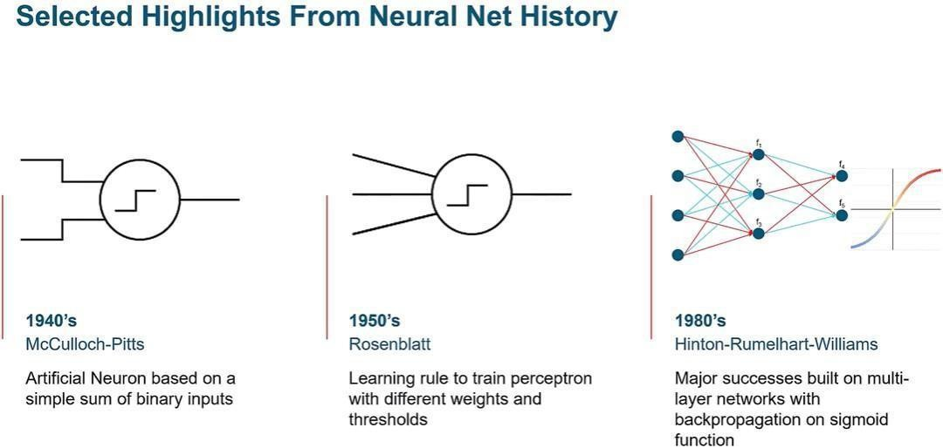

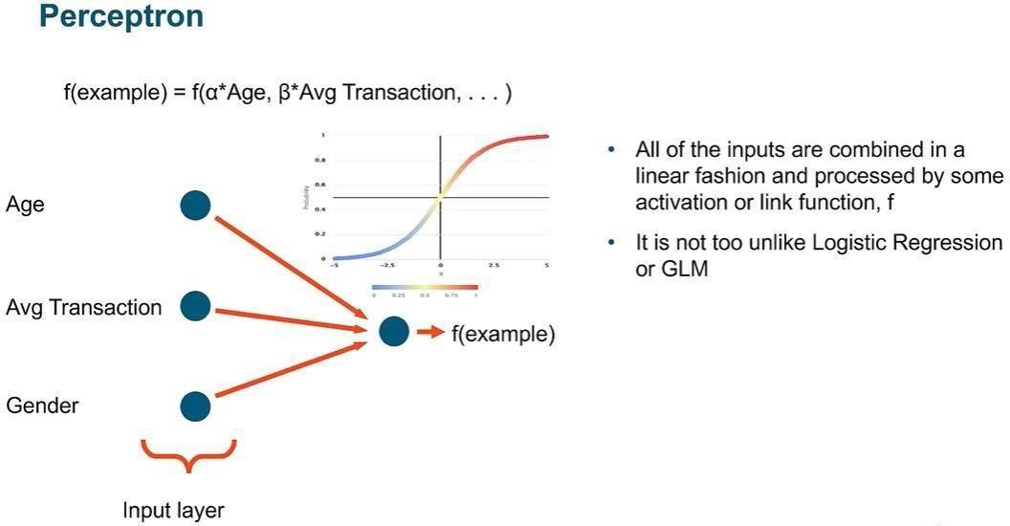



 in machine learning refers to the process of evaluating the performance of a trained model on unseen data. It's crucial because it reveals how well the model generalizes to new information and helps guide decisions about model selection and deployment. Scoring typically involves using metrics to quantify the model's performance.

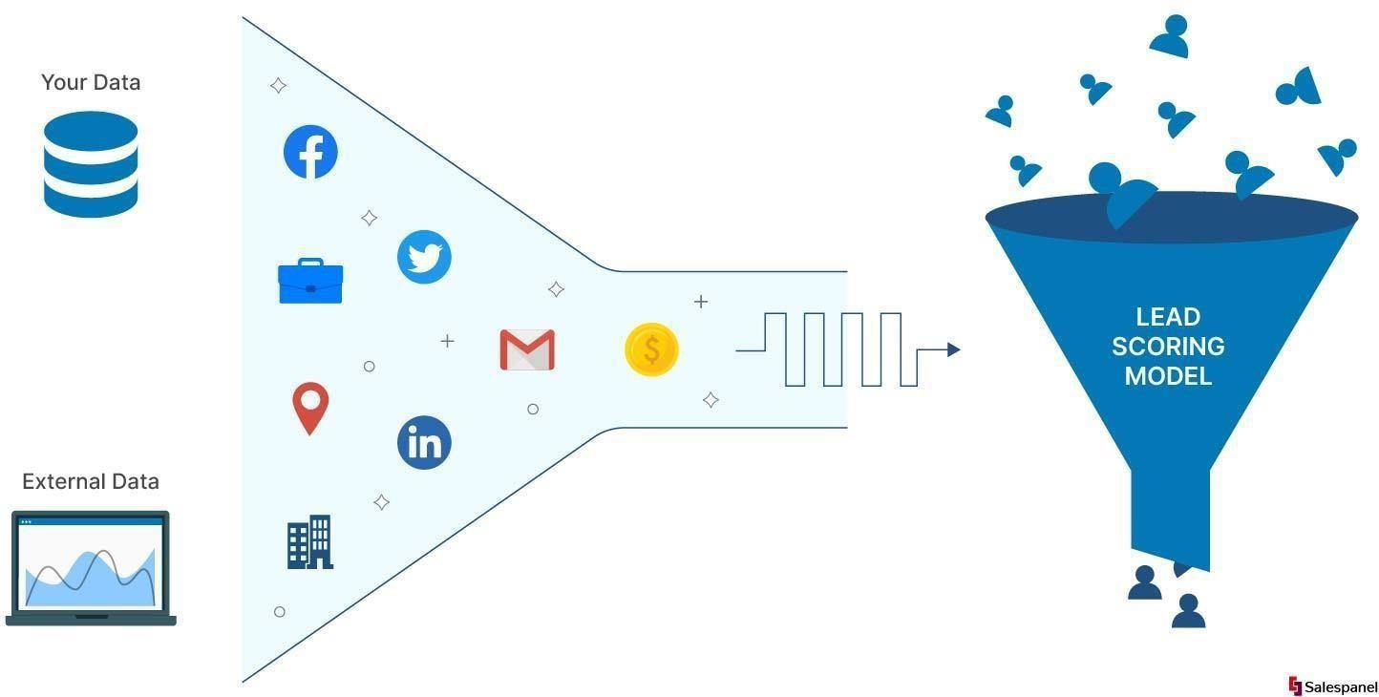





* Proportion of correctly classified instances out of the total.
* Proportion of true positive predictions out of all positive predictions.
*  Proportion of true positive predictions out of all actual positive instances.
* Harmonic mean of precision and recall, balancing the two metrics.

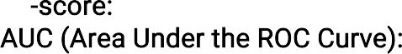

* Plots the true positive rate against

the false positive rate.



This technique assesses a model's performance by splitting the data into multiple folds, training the model on different subsets, and evaluating it on the remaining fold. This ensures the model's performance isn't overly influenced by specific training and test sets used.



*  Splitting the data into training and test sets, training on the training set, and evaluating on the test set.
*  Splitting the data into k folds, training on k-1 folds and evaluating on the remaining fold, repeating k times with each fold serving as the test set once.
*  Similar to k-fold, but ensures each fold has the same proportion of target classes as the entire dataset.
* A special case of k-fold where k is



equal to the number of instances in the dataset, meaning each instance is used as a test set once.



Scoring is also used for model selection, where multiple models are trained and evaluated, and the best-performing model is chosen for deployment. This process may involve tuning hyperparameters to improve the model's performance.



 is a machine learning approach where models are trained on unlabeled data, meaning the data doesn't have predefined categories or labels. The goal is to find hidden patterns or intrinsic structures within the data itself. This technique is particularly useful for exploratory data analysis and grouping similar data points together.





 This is a common technique that groups similar data points into clusters. It helps in understanding the natural groupings present in the data without any predefined labels. Some common clustering algorithms include K

-means, hierarchical clustering, and DBSCAN.

 This involves reducing the number of input variables in the data while preserving its essential features. This is useful when dealing with high- dimensional data. Techniques like Principal Component Analysis (PCA) and t-

distributed Stochastic Neighbor Embedding (t-SNE) are widely used for dimensionality reduction.

 Unsupervised learning can be used to identify rare events or outliers in the data that deviate from normal behavior. This is particularly useful in fraud detection, network security, and healthcare applications.

 This technique helps discover interesting relationships between variables in large databases. It is commonly used in market basket analysis to identify patterns in consumer behavior, such as products frequently purchased together.

* 

Correlation analysis is a statistical method used to assess the strength and direction of the relationship between two or more variables. In unsupervised learning, it helps understand how variables relate to each other without a predetermined outcome variable. This aids in identifying patterns and dependencies within the data.

 Correlation coefficients, such as Pearson's correlation coefficient, quantify the degree of association between variables. High values indicate a strong relationship, while low or negative values suggest a weak or inverse relationship.

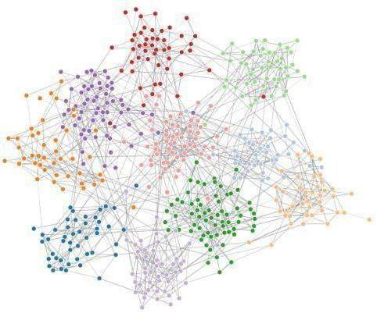

* 

Clustering is a fundamental unsupervised learning technique that groups similar data points together based on their characteristics. The goal is to partition the data into distinct groups (clusters) such that points within the same cluster are more similar to each other than those in other clusters.

 Techniques like K-means and hierarchical clustering automatically identify these clusters.

 Clustering is widely used in various applications, including:



* Customer segmentation: Grouping customers based on similar characteristics.
* Image segmentation: Segmenting images into objects or regions with similar properties.
* Anomaly detection: Identifying data points that deviate significantly from the majority.

By combining correlation analysis and clustering, we can gain deeper insights into the structure and relationships within unlabeled data. This knowledge is crucial for various unsupervised learning tasks.

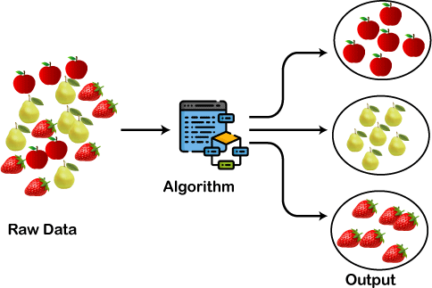

* 

Association analysis, also known as market basket analysis, is a technique used to uncover relationships between items in a dataset. It is often used in retail and e- commerce to identify patterns of co-occurrence among products purchased by customers. The goal of association analysis is to find rules that describe the relationships between items. These rules are expressed in the form of "if-then" statements, where the presence of one item in a transaction implies the presence or absence of another item. Association analysis helps businesses understand customer behavior and make informed decisions about product placement, marketing strategies, and inventory management.

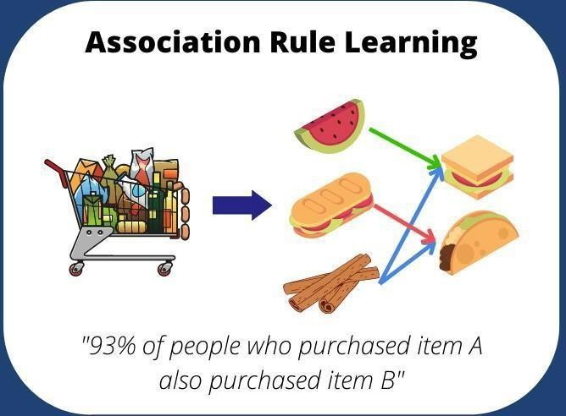

* 



Flow control is essential in data extraction processes to ensure that the data is gathered correctly and efficiently. By utilizing loops and macros, we can automate repetitive tasks and manage large datasets more effectively. This involves setting up conditions and actions that control how data is processed, ensuring that the system can handle different scenarios and exceptions.

* 



Loops and macros are fundamental tools in data science for handling repetitive tasks and complex workflows. Loops allow for the execution of a set of instructions multiple times, which is particularly useful for iterating over data sets. Macros, on the other hand, are sequences of instructions that can be triggered to perform complex operations automatically, saving time and reducing the potential for errors.

* 



Raw data files contain unprocessed data collected from various sources. These files often require cleaning and transformation before they can be analyzed. In data science, handling raw data efficiently is crucial as it forms the foundation for any analytical work. Properly managing and processing raw data ensures the accuracy and reliability of the final results.

*  

Extracting data involves retrieving information from various sources and converting it into a usable format. This process can be automated using loops and macros to handle large volumes of data seamlessly. Effective data extraction is critical for ensuring that the right data is available for analysis, enabling more accurate and insightful conclusions.

* 

Loop attributes define how loops operate within a data processing task. These attributes include the starting point, ending point, and the conditions under which the loop continues or stops. Understanding and setting the correct loop attributes is vital for optimizing data processing workflows and ensuring that tasks are completed efficiently.

* 



Automated model selection and optimization involve using algorithms to choose the

best models and fine-tune their parameters for improved performance. This process can be streamlined using loops and macros to test multiple models and configurations quickly. By

automating these tasks, we can save significant time and resources while achieving better model accuracy and performance.

* 



Error and exception handling are critical components of robust data processing systems. This involves anticipating potential errors, such as missing data or incorrect formats, and defining how the system should respond. Effective error handling ensures that the data processing continues smoothly without interruption, maintaining the integrity and reliability of the results.

* 

Branches in data processing allow for the execution of different sets of instructions based on specific conditions. This is particularly useful for handling complex workflows where different actions are required depending on the data or processing stage. By implementing branches, we can create more flexible and adaptive data processing systems that can handle a variety of scenarios efficiently.



Logging runtime values is an essential practice in process control and data science. This involves recording the values of variables and system states during the execution of a program or a data processing task. The key benefits of logging runtime values include:

1. : By logging runtime values, developers can track down and fix bugs more efficiently. It allows them to see the state of the program at various points, helping to identify where things go wrong.
2. : Logging provides real-time insights into the system’s performance and behavior. It enables continuous monitoring, allowing for the detection of anomalies and issues as they occur.
3.  : Keeping a record of runtime values creates an audit trail, which is useful for compliance and review purposes. It ensures that there is a documented history of the processes and data transformations that have taken place.
4. : By analyzing the logged values, developers can identify bottlenecks and optimize the performance of the system. It helps in understanding how different parts of the system interact and where improvements can be made.
5. : Logs are invaluable for maintaining systems, especially in complex workflows where understanding the sequence of operations and their outcomes is crucial for making adjustments and updates.



* + 

Sampling is a fundamental technique in data science used to select a subset of data from a larger dataset. The goal is to create a representative sample that can provide

insights into the overall population without the need for analyzing the entire dataset. This technique helps in reducing the computational load and speeding up the analysis process.

* + 

In sampling, it's crucial to ensure that the sample accurately reflects the population. Weighting adjusts the samples to correct any biases and make them more representative. Weighting involves assigning different weights to different samples based on their probability of selection, ensuring that the analysis results are more accurate and reliable.

* + 

Missing data is a common issue in datasets that can lead to biased results and reduce the effectiveness of data analysis. Replacing missing values with appropriate substitutes is essential for maintaining data integrity. Methods for replacing missing values include using mean, median, or mode, or applying more sophisticated techniques like regression or machine learning models.

* + 

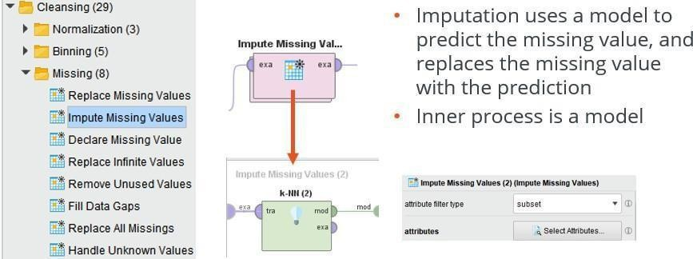

Imputation is the process of replacing missing data with substituted values. Various imputation methods can be employed, such as single imputation, where each missing value is replaced with a single estimated value, and multiple imputation, which creates several different plausible datasets and averages the results to account for the uncertainty of the missing data.

* +  

Normalizing data involves transforming the data into a standard format or scale, making it easier to compare and analyze. This process is especially important when combining data from different sources or when the data ranges vary significantly.

Common normalization techniques include min-max scaling and z-score normalization, which standardize the data to a consistent scale.

* + 

Renaming by replacement is a straightforward method to correct or standardize the naming conventions within a dataset. This can involve changing column names to more descriptive labels, correcting typographical errors, or applying a consistent naming scheme across the dataset. Proper naming conventions improve the clarity and usability of the data.

* +  



Handling missing data in time series is particularly challenging due to the sequential nature of the data. Techniques to address missing values in time series include forward filling, where missing values are replaced by the last observed value, and backward filling, where they are replaced by the next observed value. More advanced methods, like interpolation and time series forecasting models, can also be applied.

* + 

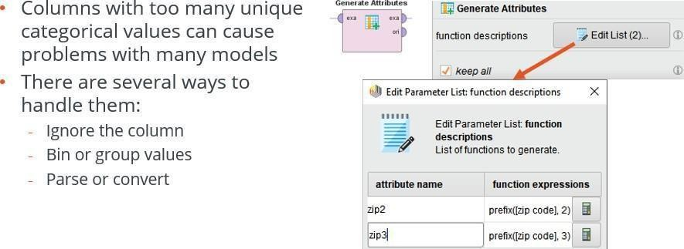

Columns with many unique values, also known as high cardinality columns, can pose challenges in data analysis. These columns can be managed by techniques such as binning, where continuous values are grouped into categories, or encoding methods like one-hot encoding and target encoding. Reducing the dimensionality of these columns can enhance the performance and interpretability of the analysis.

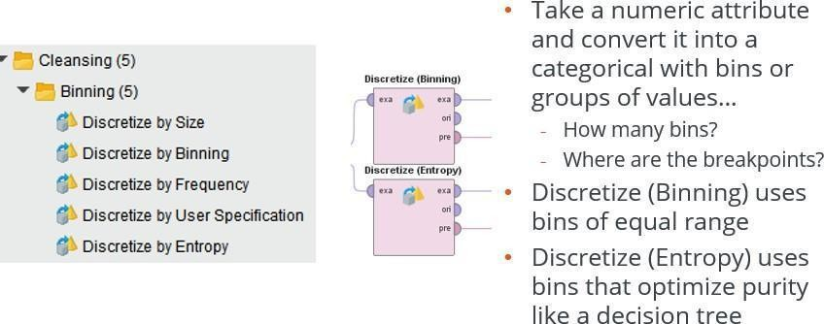

Discretize or binning is a very common data preparation and cleansing technique that does require careful thought. Many binning techniques rely on the distribution of the training data just like normalization does. When carefully implemented, discretize or binning can improve the: speed, accuracy, and interpretability of machine learning models. It's an important and commonly used technique. Here we demonstrate two techniques to discretize numeric attributes.



* + 

Overfitting occurs when a model learns the noise in the training data instead of the actual underlying pattern. This results in poor performance on new, unseen data.

Outliers can exacerbate overfitting by skewing the model's understanding of the data. Identifying and managing outliers is crucial to prevent overfitting and ensure the model generalizes well.

Outliers are data points that significantly differ from other observations. They can result from variability in the data or errors in data collection. Handling outliers involves detecting and deciding whether to remove or adjust them. Common methods include statistical techniques, such as z-scores or the IQR method, and domain- specific rules.

* +   



Visualizing data is a key step in the data cleansing process as it helps in identifying

patterns, trends, and anomalies. RapidMiner offers a variety of visualization tools to assist in this task.

: Useful for detecting outliers and understanding relationships between variables.



 : Highlight the spread of the data and identify outliers.

: Show the distribution of the data, making it easier to spot unusual values.

By using these visualization tools, data scientists can gain a better understanding of their data and identify outliers that may need to be addressed.

* 



RapidMiner's Auto Model provides automated tools for clustering and outlier detection. Clustering groups similar data points together, which can help in identifying outliers as those points that do not fit well into any cluster.

: A popular method that partitions the data into k clusters based on feature similarity. Outliers can be identified as points that do not belong to any cluster or belong to clusters with high variance.

 :



This method groups together points that are closely packed and marks points that are in low-density regions as outliers.

Using these automated tools in RapidMiner simplifies the process of detecting and handling outliers, enabling more accurate and reliable data analysis.



*  



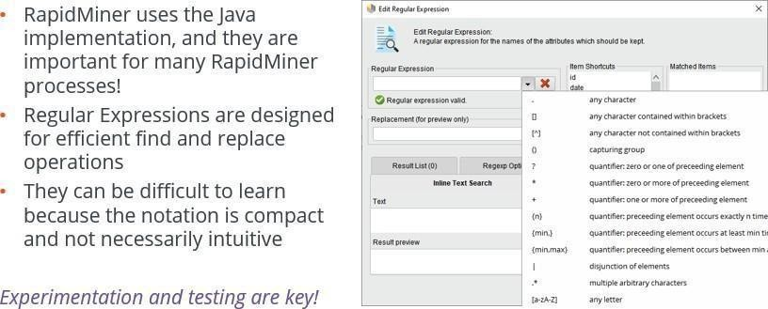

Regular expressions (regex) are powerful tools used for pattern matching and text processing. They are essential in data cleansing, validation, and extraction tasks. Here are some exercises to help you understand and apply regular expressions:

1.  : Create a regex pattern to match valid email addresses. Test it against various email formats to ensure accuracy.
2. : Write a regex pattern to identify and extract dates in different formats (e.g., MM/DD/YYYY, YYYY-MM-DD).
3.  : Use regex to find and replace specific words or phrases in a large text document.
4. : Develop a regex pattern to validate different phone number formats, ensuring they adhere to expected patterns.

By practicing these exercises, you can enhance your proficiency in using regular expressions for various data processing tasks.

* + 





Macros are sequences of instructions that automate repetitive tasks, making data processing more efficient. In RapidMiner, macros allow users to define reusable sets of operations that can be applied across different projects. They help in maintaining consistency and reducing the likelihood of errors.



Annotations are comments or notes added to macros to explain their purpose and functionality. They are crucial for documenting the logic behind the macro, making it easier for others (and yourself) to understand and modify the code in the future.

Properly annotated macros enhance code readability and maintainability.

* + 



Scripts extend the functionality of data processing tools by allowing for more complex operations and integrations. One advanced application is creating web applications that interact with data processing workflows. These web apps can provide user interfaces for data input, run scripts in the background, and display results dynamically.



Jupyter Notebooks are interactive documents that combine code, visualizations, and narrative text. Integrating Jupyter Notebooks with RapidMiner allows for seamless use of Python scripts within data processing workflows. This integration enhances the analytical capabilities by leveraging Python's extensive libraries and

visualization tools.



The Python Transformer operator expands the capability of the Execute Python operator in two primary ways:

1. It provides the ability to define the operator characteristics such as parameters, output ports, and allowable inputs.
2. It provides the ability to save just the operator in the repository for re-use.

These capabilities provide an easy way for a Python coder to encapsulate a python operation for re-use by others.



The Python Learner operator shares the following capabilities with the Python Transformer operator.

1. It provides the ability to define the operator characteristics such as parameters, output ports, and allowable inputs.
2. It provides the ability to save just the operator in the repository for re-use.

These capabilities provide an easy way for a Python coder to encapsulate a python operation for re-use by others.

The Python Learner, has a special construct that is specifically for machine learning models. It provides a unified harness for both training the model and applying or scoring the model. This is significantly different from the other Python operators because instead of a single main function, there are two: one for training and one for applying.



* +  



Text analytics is the process of converting unstructured text data into meaningful insights. This involves analyzing textual content to extract useful information, identify patterns, and derive actionable insights. Techniques such as natural language processing (NLP), sentiment analysis, and topic modeling are commonly used in text analytics to understand and interpret text data.

* +   



Loading text data into RapidMiner is the first step in text analytics. RapidMiner provides various operators to import text from different sources, including files, databases, and web pages. Once the text is loaded, it can be preprocessed and transformed for further analysis. This involves cleaning the text, removing stopwords, and converting it into a suitable format for analysis.

* +  

Processing text and document objects in RapidMiner involves several steps to prepare the data for analysis. This includes tokenization (breaking text into words or phrases), stemming (reducing words to their base form), and vectorization (converting text into numerical representations). These steps are crucial for transforming raw text into structured data that

* + 



Text association rules help in discovering relationships between words or phrases in a text corpus. These rules can reveal patterns and associations that are not immediately apparent, providing deeper insights into the data. For example, association rules can identify frequently co-occurring terms, which can be useful for tasks like market basket analysis in text data.

* +  

Document similarity and clustering involve grouping similar documents together based on their content. Techniques like cosine similarity, Jaccard index, and hierarchical clustering are used to measure the similarity between documents and organize them into clusters. This helps in identifying themes, categorizing large collections of documents, and finding duplicates or related documents.

* + 

Automatic classification of documents uses machine learning algorithms to assign predefined categories to documents based on their content. This involves training a model on a labeled dataset and using it to classify new, unseen documents.

Techniques like Naive Bayes, SVM, and deep learning models are commonly used for document classification tasks.

* + 



Once a model is trained, it can be applied to categorize new documents. This involves loading the model and the new documents into RapidMiner and using the model to predict the categories for each document. The results can be evaluated and fine-tuned to improve the accuracy and performance of the model. Automating this process allows for efficient handling of large volumes of text data, enabling quick and accurate categorization.





Cross-validation is a robust technique used to evaluate the performance of a machine learning model. It involves partitioning the dataset into multiple subsets, training the model on some subsets while testing it on others. This process is repeated several times to ensure that the model's performance is reliable and not dependent on a

particular division of the data.

Common methods include k-fold cross-validation and stratified k-fold cross- validation, which help in assessing the model's generalizability to new, unseen data.



The Area Under the Receiver Operating Characteristic Curve (AUC-ROC) is a popular metric for evaluating the performance of classification models. It measures the model's ability to distinguish between classes. AUC-ROC provides a single value that represents the model's performance across all classification thresholds, making it a valuable tool for comparing different models and selecting the best one.

* + 

Performance costs refer to the costs associated with different types of errors made by a model. In many real-world scenarios, different types of misclassifications have different implications. For example, in a medical diagnosis context, a false negative (failing to identify a disease) might be more costly than a false positive (incorrectly diagnosing a disease).

Understanding and incorporating performance costs into model evaluation helps in developing models that are not only accurate but also aligned with the specific needs and constraints of the application.

* + 



Cost-sensitive scoring involves adjusting the model's evaluation metrics to account for different costs associated with false positives and false negatives. This approach helps in optimizing the model's performance based on the specific cost structure of the problem at hand. By understanding the impact of these costs, data scientists can make more informed decisions and create models that minimize the overall cost, rather than just maximizing accuracy.

Thresholds in machine learning refer to the decision boundary that determines the class label assigned to a prediction. Adjusting the threshold can significantly impact the model's performance, particularly in terms of precision and recall. Finding the optimal threshold involves balancing these metrics to achieve the desired trade-off between sensitivity (true positive rate) and specificity (true negative rate).

Understanding and setting appropriate thresholds is crucial for tailoring the model's performance to specific application requirements.



* + 

In classification tasks, several performance measures are commonly used to evaluate the effectiveness of a model:

 The number of correctly predicted positive instances.  The number of correctly predicted negative instances.

actually negative. actually positive.

The number of instances predicted as positive but are The number of instances predicted as negative but are

The proportion of correctly



predicted positive instances among all instances predicted as positive.

 The proportion of correctly predicted negative instances among all instances predicted as negative.

The proportion of correctly predicted positive instances among all actual positive instances.



 The proportion of correctly predicted negative instances among all actual negative instances.

  The harmonic mean of precision and recall, providing a balanced measure of the classifier's performance.

 The ROC curve is a graphical representation of the true positive rate against the false positive rate at various threshold settings. The Area Under the Curve (AUC) is a single value representing the performance of the classifier, with a higher AUC indicating a better classifier.

* + 

In regression tasks, the following performance measures are commonly used to assess the quality of the model's predictions:

  The average of the absolute differences between the predicted values and the actual values.

  The average of the squared differences between the predicted values and the actual values.

  The square root of the MSE, providing a

measure of the spread of errors.

 The proportion of the variance in the

dependent variable that is predictable from the independent variables.

 A modification of R-squared that adjusts for the number of predictors in the model.

  The average of the absolute percentage differences between the predicted values and the actual values.

These performance measures provide valuable insights into the effectiveness of classification and regression models, helping data scientists and analysts evaluate and compare different models' performance.



* + 

Feature generation is the process of creating new features from existing data to improve the performance of machine learning models. This involves transforming raw data into a set of features that better represent the underlying patterns and relationships. Effective feature generation can significantly enhance the model's ability to learn and make accurate predictions. Techniques such as polynomial features, interaction terms, and domain-specific transformations are commonly used to generate meaningful features.

* + 

Feature selection is the process of identifying the most relevant features for use in model training. By selecting only the most important features, we can reduce the complexity of the model, improve its performance, and prevent overfitting. Common techniques for feature selection include filter methods (e.g., correlation coefficients, chi-square tests), wrapper methods (e.g., recursive feature elimination), and embedded methods (e.g., feature importance from tree-based models).

* +  

Automatic feature engineering uses algorithms to automate the process of generating and selecting features. RapidMiner's Auto Model simplifies this task by automatically creating a variety of features and selecting the most relevant ones based on their predictive power. This approach saves time and ensures that the best possible features are used in the model, improving its performance without requiring extensive manual intervention.

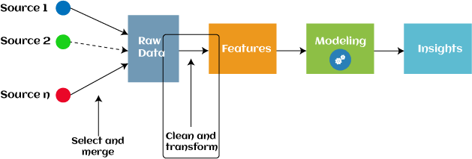

* + 

Principal Components Analysis (PCA) is a dimensionality reduction technique that transforms the original features into a new set of uncorrelated variables called principal components. These components capture the maximum variance in the data with the fewest number of variables. PCA is particularly useful for reducing the number of features while retaining the essential information, thereby simplifying the model and reducing computational costs.



* +  

Parameter optimization is the process of finding the best parameters for a machine learning model to achieve optimal performance. It involves techniques such as grid search, random search, and Bayesian optimization to search through a specified parameter space and determine the combination that maximizes the model's accuracy or other chosen metric.

* +  

Evolutionary parameter optimization uses evolutionary algorithms inspired by natural selection to explore and optimize model parameters. These algorithms mimic biological evolution by iteratively refining a population of potential solutions through selection, crossover, and mutation operations, aiming to find the optimal set of parameters for the model.

* + 



Automated model selection involves using algorithms to automatically select the best- performing model from a set of candidates. This process includes evaluating multiple models based on predefined metrics and selecting the one that offers the highest predictive accuracy or meets other specified criteria.

Finding the right model involves comparing and evaluating different machine learning algorithms to determine which one best fits the specific problem and dataset. Factors to consider include model complexity, interpretability, and performance on validation data.

* + 



RapidMiner provides various tools and operators for model operations, including training, testing, and deploying machine learning models. These operations are

essential for developing predictive models and integrating them into data-driven applications.

* + 



Model management in RapidMiner involves tasks such as versioning, monitoring performance over time, and retraining models as new data becomes available.

Effective model management ensures that deployed models remain accurate and reliable throughout their lifecycle.



Supervised learning is a type of machine learning where the model is trained on a labeled dataset, meaning that each training example is paired with the correct label or output. The goal of supervised learning is to learn a mapping from input variables to output variables, so that the model can make predictions on new, unseen data.

Supervised learning can be broadly categorized into two main types:

1. : Regression is used when the output variable is a continuous value. The goal of regression is to predict a value based on input variables. Examples include predicting house prices based on features like size, location, and number of rooms.
2. : Classification is used when the output variable is a category or label. The goal of classification is to predict the class label of new observations based on past observations with known labels. Examples include spam detection in emails, image classification, and sentiment analysis.

In supervised learning, the model learns from labeled training data and is evaluated on its ability to generalize to new, unseen data. Common algorithms used in supervised learning include linear regression, logistic regression, decision trees, random forests, support vector machines, and neural networks.



* +  



Ensemble learning combines multiple models to improve predictive performance. By leveraging the strengths of different models, ensembles can achieve higher accuracy and robustness than individual models.

* + 

Ensemble methods such as bagging, boosting, and stacking are popular techniques for creating ensembles. These methods vary in how they combine individual models and manage diversity to enhance overall prediction accuracy.

* +   

Ensembles reduce prediction errors by averaging out individual model biases and errors. By combining diverse models that excel in different areas, ensembles can achieve better generalization and robustness on unseen data.



Support Vector Machines (SVM) are powerful supervised learning models used for classification and regression tasks. SVM finds the optimal hyperplane that separates data points into different classes or predicts continuous outcomes based on training data.



Deep learning is a subset of machine learning that uses artificial neural networks with multiple layers to learn intricate patterns from large amounts of data. It excels in tasks such as image recognition, natural language processing, and speech recognition.

* + 



Deep learning extensions in RapidMiner provide operators and tools to build and train deep neural networks efficiently within the RapidMiner environment.

* + 

Deep learning models can be used for classification tasks where the goal is to assign input data points to predefined categories based on their features.

* + 

Deep learning models can also be applied to regression tasks, where the goal is to predict continuous values based on input data features.

6. SparkRM & Radoop

RapidMiner Studio takes data processing to a new level with SparkRM and Radoop, powerful extensions that harness the capabilities of Apache Spark. This datasheet explores how these extensions can revolutionize your data science workflows.

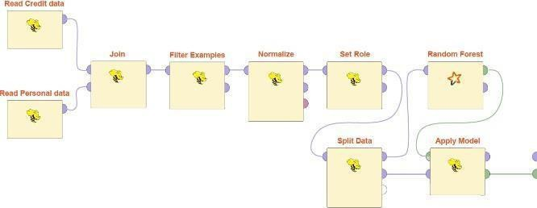

SparkRM simplifies working with Spark within RapidMiner. It enables parallel execution of operations and data flows on a Hadoop environment using Spark. This approach unlocks a wider range of use cases and allows for more sophisticated algorithms compared to traditional MLlib methods.

SparkRM seamlessly integrates with your existing RapidMiner workflows, eliminating connection complexities and providing a user-friendly experience.



Radoop builds upon SparkRM's capabilities by enabling computations to be pushed to your existing Hadoop or Spark infrastructure. This frees data scientists from managing infrastructure, allowing them to focus on core data science tasks. Radoop empowers you to efficiently train models with large datasets in Hadoop and create lightweight scoring processes in memory. This translates to significant gains in scalability and efficiency for your data processing tasks.

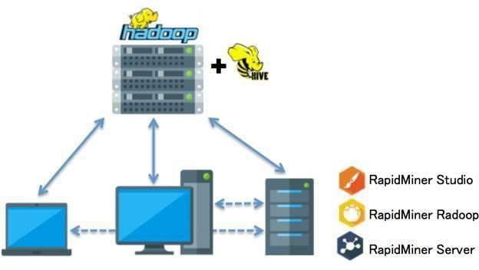

Data security is paramount, especially in distributed computing environments. RapidMiner Radoop adheres to strict Hadoop data security standards, ensuring centralized management of analytic workflows without compromising IT regulations. It supports advanced security features such as Kerberos authentication, Hadoop impersonation, and integration with Apache Sentry & Ranger for data access control. Additionally, Radoop seamlessly integrates with HDFS encryption for the highest level of data security.



The combined power of RapidMiner Studio, SparkRM, and Radoop offers a comprehensive suite of functionalities:

*  Build and manage visual workflows with ease.



*   Integrate SparkR and PySpark scripts seamlessly within your visual processes.
* Run analytic workflows directly on the data source.



* Ensure transparency and ease of use for data access, preparation, and modeling tasks.
*  Read, store, and append data from/to Hive tables, supporting various file formats.
*  Perform K-Means clustering, Principal Component Analysis, and more.
*   Leverage Kerberos authentication, data access authorization, and HDFS encryption.
*   Efficiently process data and execute models through seamless data exchange between local memory and the Hadoop cluster.





*  Leverage the distributed computing power of Apache Spark and Hadoop to efficiently process massive datasets.
*  Handle large data volumes without compromising on processing speed.





*   Access a wide range of advanced analytics and machine learning algorithms optimized for distributed computing environments.
*   Derive valuable insights from your data quickly and effectively.





*  Analyze and act on data as it's generated, ideal for applications requiring real-time insights like fraud detection and IoT analytics.





*   SparkRM and Radoop integrate smoothly with RapidMiner Studio, providing a familiar and user-friendly environment for developing and running data workflows.
*   Existing RapidMiner users can easily transition to leverage Spark and Hadoop capabilities.



*  Access and process data from various sources, including flat files, Amazon S3, and common relational databases.





* Build and execute data pipelines with ease using the drag-and- drop interface. No coding required!



* The intuitive interface makes working with SparkRM and Radoop straightforward for users of all experience levels.

